G.B.W. Financial Planners

**P.O. BOX 10001, CAPE TOWN, 8000, 39 Buitenkant Street, Cape Town, 8001**

**Tel. 021 – 461 0685, Fax. 086 615 2320, E-mail.** [**cgillot@comail.co.za**](mailto:cgillot@comail.co.za)**,**

**Authorised FSP No. 44140**

**In Touch November 2018**

This time last year, there was national discontent as the nation began to find out through the media about State Capture. Twelve months on, and the extent to which the capture has spread, has shocked every decent tax paying citizen. Its like pulling out weeds. You see that the roots have formed a network of corruption spread across every area of Government.

We are grateful for the new direction South Africa is heading in, and the Rating Agencies are cautiously optimistic. As I have said before, we can expect the Rand to continue to bounce around until the government gives certainty to the markets. Our top 40 JSE shares are still good winners – since most of them have off shore exposure. Stay invested and stay the course as any Asset Manager will tell you. It has been difficult though for those who draw income above the inflation rate.

You may also be experiencing difficulties relating to bank and Insured products. That is because of the new legislation which has come down hard on what the new FSCA calls an ‘Accountable Institution’. In terms of the new rules, none of the current corruption would have happened had these rules been in place. To this end, our task has become very onerous and we ask clients to please understand the pressure we are under to ensure correctness in documentation that needs to be completed in the course of business.

Before you break for the festive season, please re visit your Last Will and Testament. If you need to make changes, call your broker and do what needs to be done.

**The comments and graph below are from the Foord newsletter dated 19 November 2018.This is a difficult environment for investment managers but also for investors. The most important strategy in times like this is to stay the course. We have purposely repeated this message recently in anticipation of the current environment and in the knowledge that it is impossible to time such market moves.**

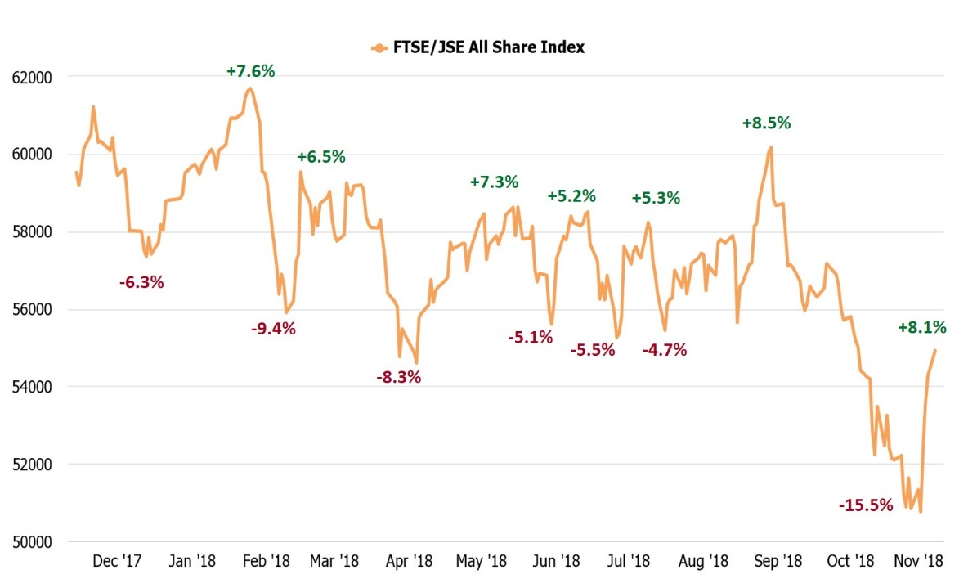

May you all have a rest full time catching up with family and friends. We at GBW

wish you the very best and look forward to a brighter day.

**The Team**

**Isheesha Trading & Investments T/a G.B.W. Financial Planners Reg.no. 2010/016686/07**